Dis-Eur-Czech-**Těšetice-Kyjo-Venus figurines**

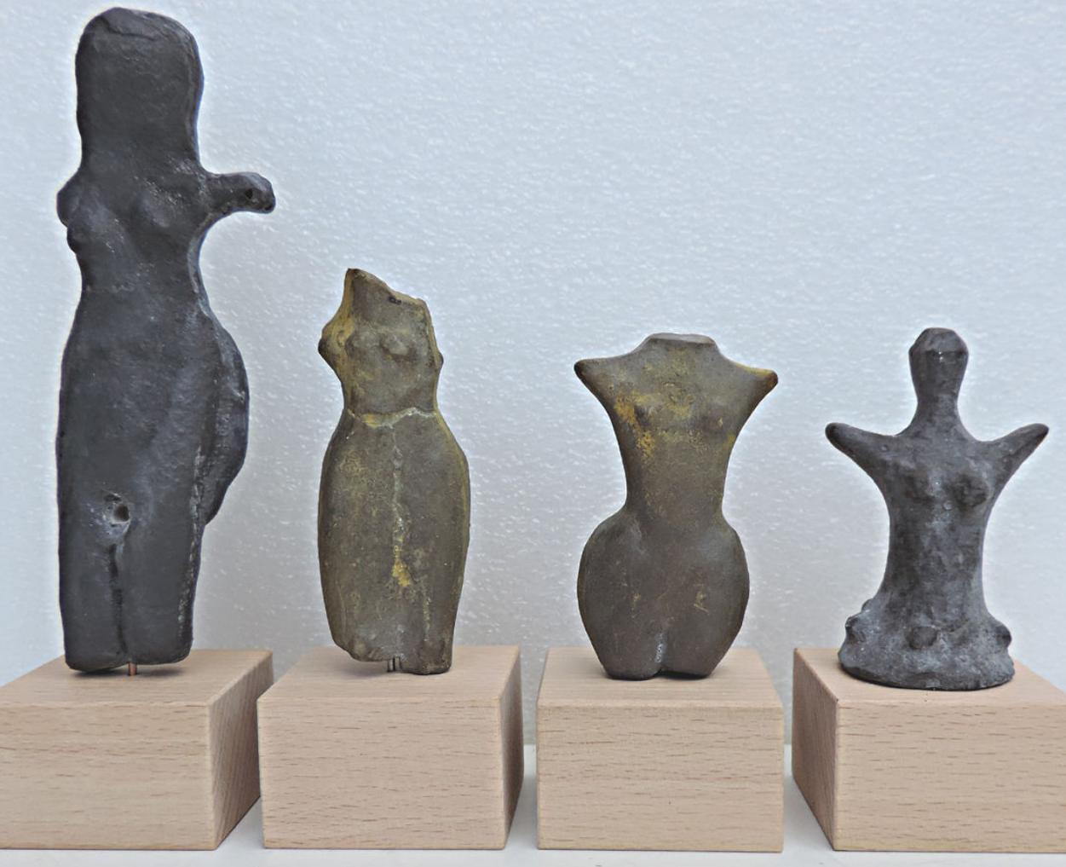

**Czech Republic: Moravia.**  
**Age:** Neolit - about 4 600 - 4 400 Years BC  
**Size of greatest Venus: 13 cm (5,1 inches).  
Material of original: Baked clay.**

**from Těšetice-Kyjovice -** casts of resin.